**Question Bank**

**Unit II**

1. List and explain the different features of C

Ans: Features of C include:

* Structured programming language:
  + We can break the program into parts using functions
  + Easy to understand and modify
  + Provides code reusability
* Rich library: inbuilt functions make the development faster
* Memory management: dynamic memory management
* Statically typed: the type of variable is checked at compile time and not run time.
* Easy to extend: features and operations can be added

1. Justify why C is considered as a Middle Level Language

Ans:

1. Explain the structure of a C program with an example

Ans:

* c prog contains one or more functions, where a function is defined as a group of statements that perform a well-defined task.
* The statements are written in logical sequence
* The main() function is most imp func
* 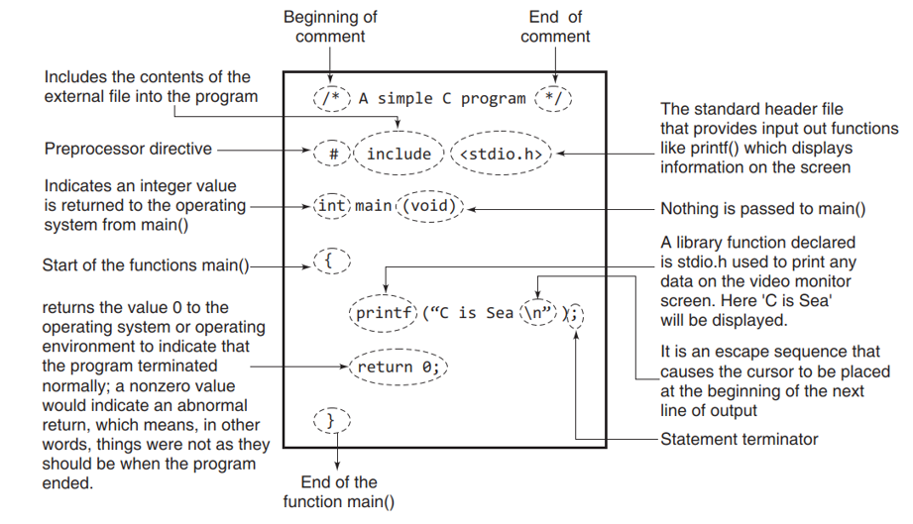

1. List and explain any 5 header files with example

Ans:

* stdio.h: for standardized i/p and o/p functions
* string.h: for string handling functions
* stdlib.h: for some misc func
* math.h: for mathematical funcs
* alloc.h: for dynamic memory allocation
* conio.h: for cleaning screen

1. How do we compile and run a C Program

Ans:

* The editor is used to create and modify the program code while the complier transforms the source code to object code for the computer to understand.
* Pre-processing is the first phase of c compilation. It processes include files, conditional compilations and macros.
* Compilation is the second pass. The complier examines each program statement contained in the source code and checks it to ensure that it conforms to the syntax and semantics of the language.
* Errors spotted by the complier are reported to the user. These errors must be corrected and the program must be recompiled.
* Linking is the final stage of compilation. After the program has been translated to object code, it is ready to be linked.
* The purpose of linking phase is to get the program into a final form for execution.
* The process of compiling and linking is often called building.

1. Give the differences between Compile Error and Runtime Error

Ans:

* Compile errors: given by the compiler and prevent the program form running
* Runtime error: given by the operating system.

1. Elaborate C Tokens in detail

Ans:

* Tokens represent the individual entity of language.
* The different tokens in c are:
  + Keywords: reserved words that cannot be used as an identifier. Each keyword has a fixed function.
  + Identifiers: names given to program elements such as variables, arrays and functions.
  + Others include, operators, strings, constants, special symbols

1. What is an identifier? List the different rules to define an identifier. Give examples

Ans:

* Identifiers are names given to program elements such as variables, arrays and functions.
* Rules to define an identifier:
  + Must contain only letters, digits and underscore. Special characters are not allowed.
  + Cannot start with a digit.
  + Should not be a keyword.
  + Must not contain white space.
  + Should be up to 31 characters long. First 31 characters are considered significant.

1. Write a short note on the basic data types in C
2. Give the range and size of different data types in C

Ans:

* Data types determine the set of values that a data item can take and the operations that can be performed on the item.
* There are 4 basic data types:
  + char: to stores characters.
  + int: to store integer numbers
  + float: to store floating point numbers
  + double: to store big floating point numbers

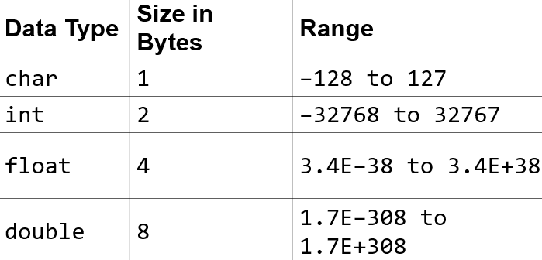

VARIABLES: (type of identifier) name given to a storage area.

* declaring variables: int marks;
* initializing variables: int marks = 90;

CONSTANTS is a value that cannot be altered in a program.

* declaring constants: const float pi= 3.14;
* character constants: “a”,”F”
* string constants: “good”,”hello”

ESCPE SEQUENCE: characters which cannot be typed or has special meaning.

* 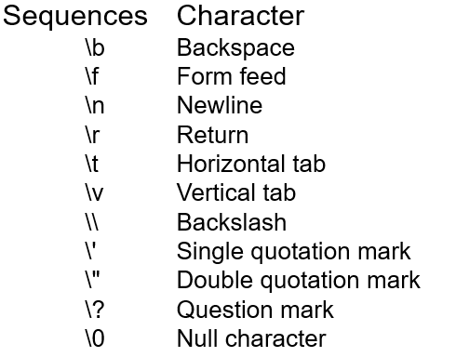

1. Write a program to print the message “Welcome to RV” in C

Ans:

#include <stdio.h>

int main(void)

{

printf(“Welcome to RV”);

return 0;

}

1. Write a program to perform (i) add (ii) Subtract (iii)multiply and (iv) divide two numeric variables and display the output in C

Ans:

#include <stdio.h>

int main(void)

{

int a=3,b=4,ch;

printf(“enter choice: 1.add,2.subtract,3.multiply,4.divide”)

scanf(“%d”,&ch)

swich(ch)

{

case “1”:

printf(“sum is: %d”,a+b);

case “2”:

printf(“difference is: %d”,a-b);

case “3”:

printf(“multiplication is: %d”,a*b);

case “4”:

printf(“division is: %d”,a/b);

}

return 0;

}

**[Similar simple programs to be practiced]**

1. Discuss the (i) Arithmetic (ii)Logical and (iii)Relational operators in C with Example

Ans: d

* Arithematic operators:
  + +,-,*,/,% : do table and give example of each
  + int a=9, b=3, result;
  + 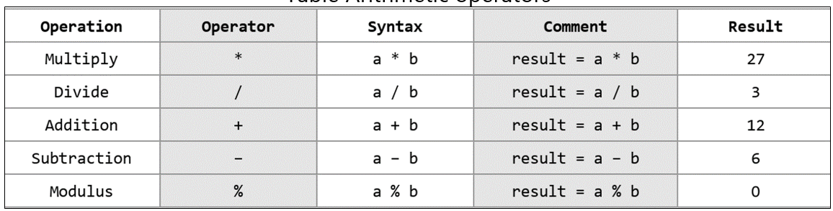
  + Here, a and b are operands
* Logical:
  + AND (&&), OR ( || ), NOT ( ! ),
  + Ex: 2>5 && 6<=9 <output is 0>
* Relational: (aka comparison operation). Returns Boolean value.
  + A screenshot of a computer

    AI-generated content may be incorrect.
* Equality operators:
  + A close-up of a white paper

    AI-generated content may be incorrect.
* Conditional operator (ternary operators)
  + Syntax: condition ? yes : no
* Assignment operators:
  + int x = 10
  + A table with text and symbols

    AI-generated content may be incorrect.

1. Explain the working of bitwise operators in detail

Ans:

* performs operations at a bit level.
* bitwise AND, OR, XOR, NOT
* AND: 10101010 & 01010101 = 00000000
* OR: 10101010 | 01010101 = 11111111
* XOR: 10101010 ^ 01010101 = 11111111
* NOT: ~10101011 = 01010100

1. Explain operator precedence in detail

Ans: c lang supports in the order of precedence (highest to lowest).

The associativity indicates the order in which the operators of equal precedence in an expression are evaluated.

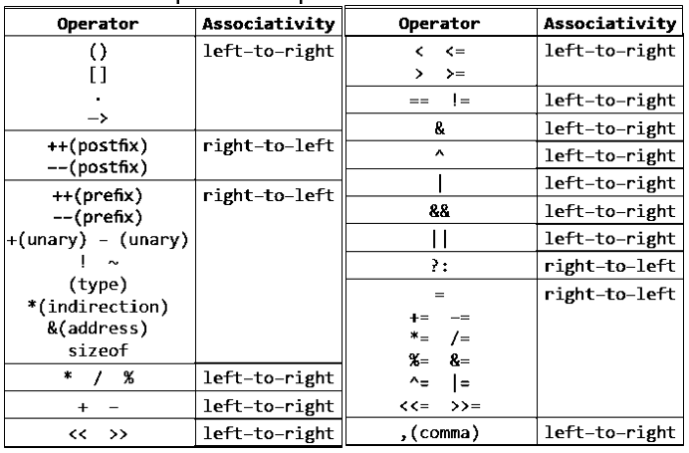

1. With example any five-escape sequence characters that help to format the output in C

Ans:

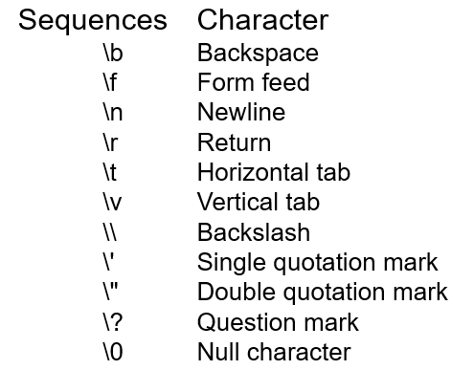

1. What is typecasting and how is it useful?
2. How do type conversion work in C ? Give an example

Ans: changing a variable from one datatype to another.

• Type conversion is done implicitly. When expression has variables of different datatypes.

• float x;

• int y = 3;

• x = y;

• Now, x = 3.0, as integer value is automatically converted into its equivalent floating point representation.

• Type casting is done explicitly. Also called forced conversion. When value of one datatype has to be converted into value of another datatype.

• float salary = 10000.00;

• int sal;

• sal = (int) salary;

1. Explain increment and decrement operators in C with relevant example

Ans: The increment operator is a unary operator that increases the value of its operand by 1. Similarly, the decrement operator decreases the value of its operand by 1.

The increment/decrement operators have two variants: prefix and postfix. In a prefix expression (++x or – –x), the operator is applied before the operand while in a postfix expression (x++ or x– –), the operator is applied after the operand.

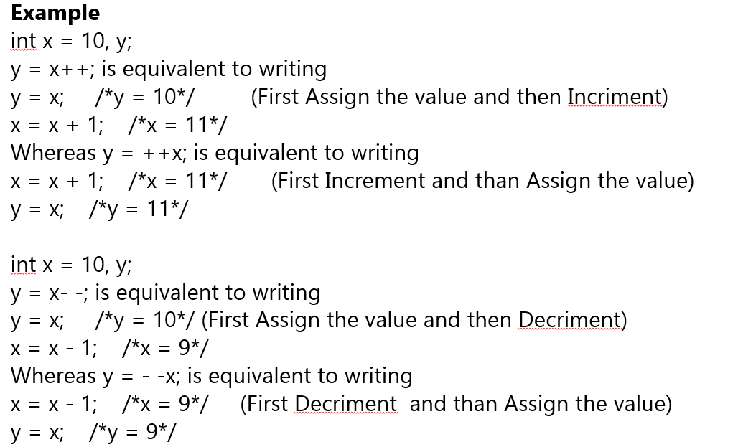

1. What is role of local and global variables in C? Give examples

Ans:

* Global:
  + Global variables are defined outside of all the functions, usually on top of the program.
  + The global variables will hold their type throughout the life-time of your program.
  + A global variable can be accessed by any function.
* Local:
  + Variables that are declared inside a function or block are local variables.
  + They can be used only by statements that are inside that function or block of code.
  + Local variables are not known to functions outside their own.
* Example:
  + 